**Lab 1: Computer Circuit Simulation**

**Objective:**

To learn how to use a circuit simulation tool to analyze and simulate circuit performance.

**Equipment and Components:**

* Circuit simulation software: NI Multisim

**Preliminary:**

Full versions of NI Multisim are available in ECE Labs. Student versions are available from the vendors’ websites. The links to the corresponding sites and their tutorials can be found in the appendix.

* Read through the tutorial and record in your lab book any “key” concepts that may be needed to complete this lab.

**Procedure:**

1. Using Multisim, create the circuit shown in Figure 1.1. Please make sure to include the ground terminal. Include a copy of the schematic in your lab book.

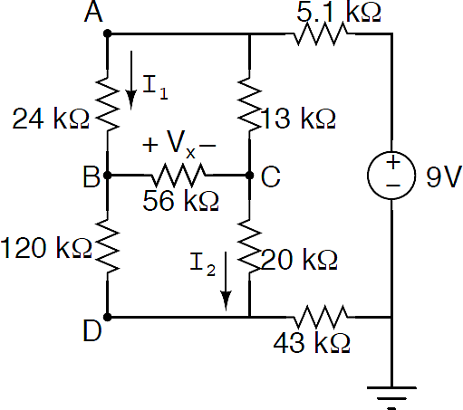

Figure 1.1 Circuit to be simulated

1. Now, add voltage and current probes to monitor I1, I2, and Vx and run a Bias Point (DC Operating Point or .op) analysis. In LTSpice, the results are displayed in a separate window after you run the simulation. Include the results in your lab book.
2. Run a DC Sweep analysis of the circuit shown in Fig.1.1 where Vs (9 V dc voltage source) is swept from-5 to 9 Volts in 0.5 step increments. Plot two graphs, one for the currents (I1, I2), and one for the voltage (Vx). Both graphs should have the same x-scale (y axes are either currents or voltage and x axis is Vs). Include a copy of the results in your lab book.

**Conclusion:**

Summarize in a list the key points that may be useful in future labs and draw conclusions about the friendliness and power of the circuit simulator.

**Appendix A: Simulation Software**

**NI Multisim (**<http://www.ni.com/multisim/>)

Multisim is a SPICE1 software for designing and simulating circuits.

Tutorials:

* <http://www.g9toengineering.com/thewellroundedengineer/MultiSimtutorial%201.pdf>
* <http://www.sonoma.edu/users/m/marivani/es231/Multisim_Interface.pdf>

**LTSpice (**<http://www.linear.com/designtools/software/>)

LTSpice is also a graphical SPICE program, which allows you to simulate a large variety of circuits. It is available for free.

Tutorials:

* <http://denethor.wlu.ca/ltspice>
* <http://ltwiki.org/index.php5?title=SPICE_and_LTspice_Courseware_and_Tutorials>

----------------------------------------------------------------------------------

1SPICE: **S**imulation **P**rogram with **I**ntegrated **C**ircuit **E**mphasis